**Summary Dashboard:**

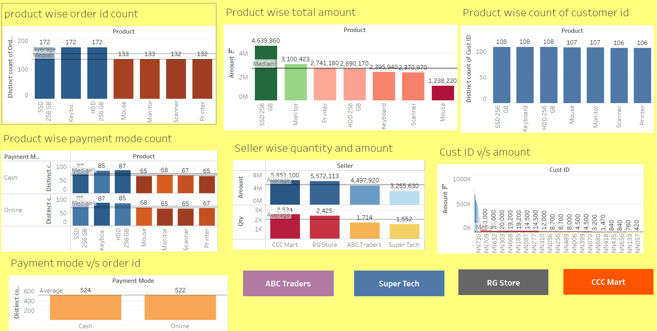

Maximum number of orders (172) were placed for the product SSD 256 GB.

Minimum number of orders (132) were placed for the product printer.

Product SSD 256 GB was sold for maximum amount.

Maximum orders (108) were placed for the same product SSD 256 GB.

For every product, almost equal number of orders were placed through cash and online mode.

Maximum number of orders and amount were sold by CCC Mart store.

Customer with ID NN730 purchased quantity worth maximum amount

Order Payment through online and cash mode is almost equal.

**ABC Traders Dashboard:**

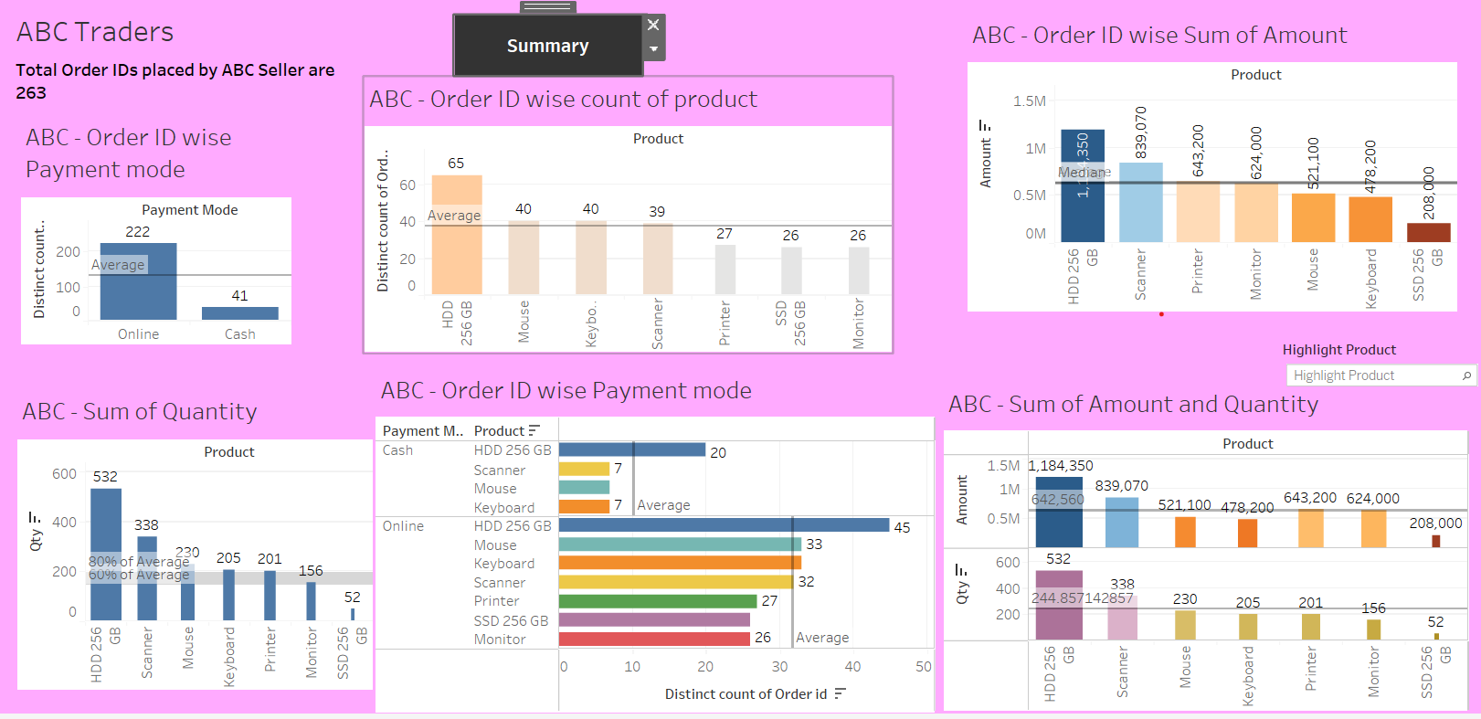

Total number of orders placed by ABC Traders is 263.

Maximum number (65) of orders were placed for the product HDD 256 GB.

Minimum number (26) of orders were placed for the product Monitor.

Maximum Amount was sold for the product HDD 256 GB.

Maximum quantity was sold for the same product HDD 256 GB.

There is a huge difference between the number of orders that received online payment and the number of orders that received cash payment.

**Super Tech Mart Dashboard:**

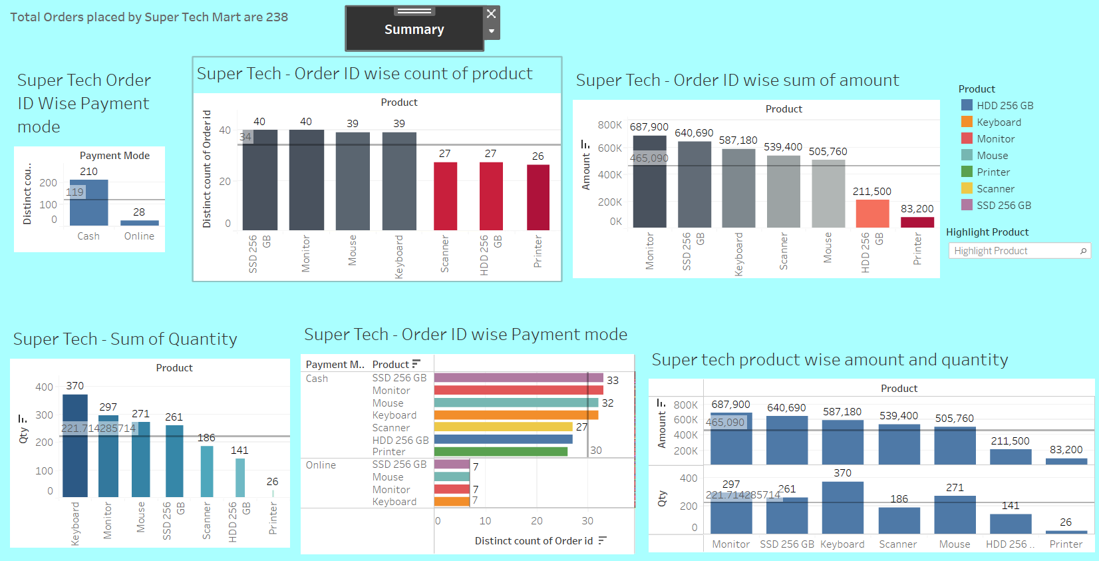

Maximum number of orders were placed for the product SSD 256 GB.

Maximum amount was sold for the product Monitor.

Maximum quantity of keyboard product was sold.

There is a huge difference between the number of cash payments and the number of online payments.

**RG Store Dashboard:**

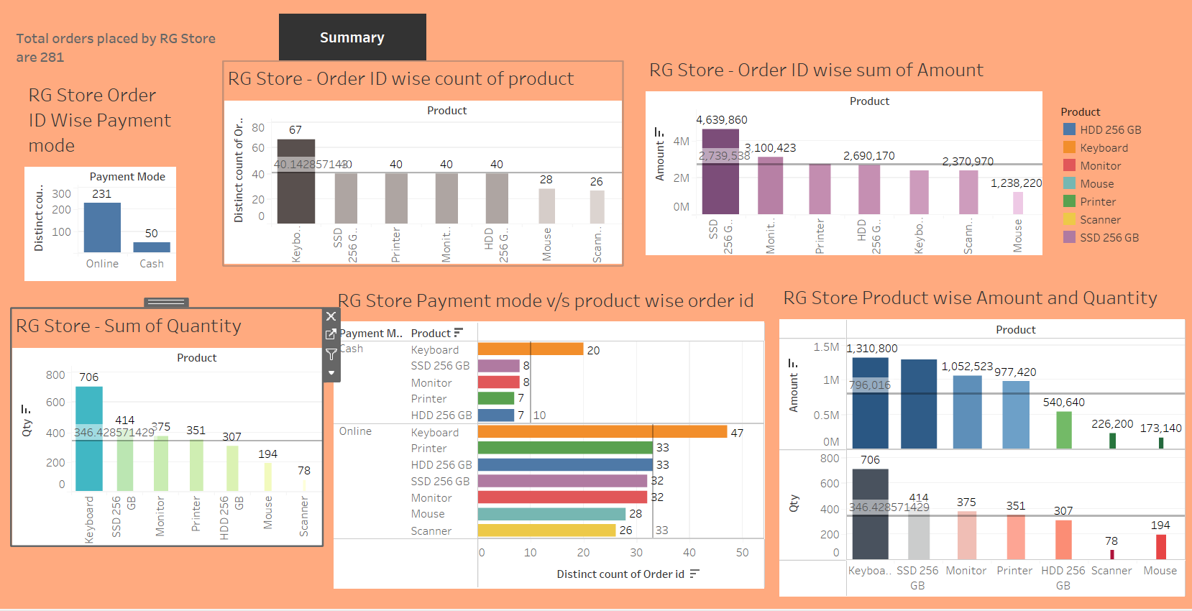

Maximum number of orders were placed for the product keyboard.

Maximum amount was sold for the product SSD 256 GB

Maximum quantity was sold for the product SSD 256 GB

There is a huge difference between the number of online and cash payments.

**CCC Mart Dashboard:**

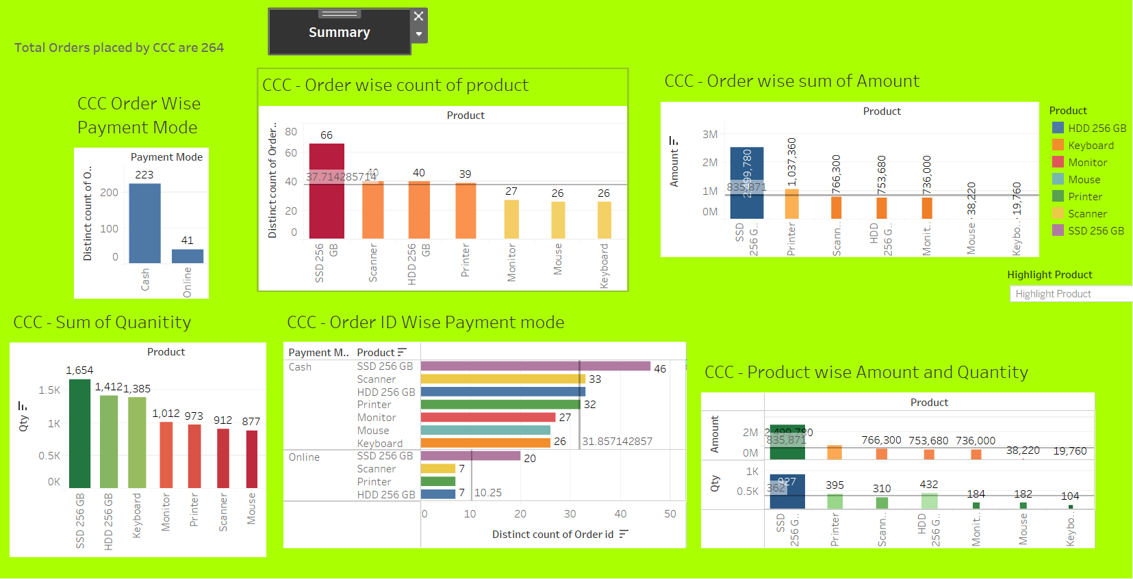

Maximum number of orders were placed for the product SSD 256 GB.

Maximum amount was sold for the same product SSD 256 GB.

Maximum quantity was also sold for the same product.

There is a huge difference between the number of cash payments and the number of online payments.